Feedback for v1.272

Overall
- There is going to be a privacy issue with the Load showing different client scenarios – I don’t want clients to be able to see other client names. Can you suggest a way to overcome this?
- “Save As” button doesn’t need to be blue or highlighted

Client Details
- Looks like Cashflow Projections have reverted back into this section. Can we please move these to the top of the “Projections” tab? These are assumptions, they should be in the client details section to be updated before running an optimisation.
- Replace “Tax Treatment” with “Tax Treatment (Income)” and add “Tax Treatment (Capital Gains)” then pull the appropriate data from the Tax Rates in the hidden widget page
- Replace “Group Constraint” with “Group Constraint (Max %)”

Optimisation
- The “Pre-tax” toggle doesn’t seem to do anything. It would be a good feature to add this as an overlay on the existing data
- Do you have metrics for “Forecast Confidence”? ie what does “High” actually mean? Is this 9/10 confidence? How is it calculated? When would I not use “High”?
- What is the “Applied 15% Cap to indices: 5,6,7” in the debug? These are constraints, we can have some global default constraints that can be controlled.
- What does the Debug button do? Shows outputted results of an optimised run if you want to check the finer details.
- Can both x and y-axes be fixed to start at 0.0%
- There seems to be an anomoly with the calculation of portfolio 1 for superannuation (accumulation phase and accumulation) when I constrain the cash holding to say 2% – it presents as an outlier showing unexpectedly high risk – can you please check the calculations
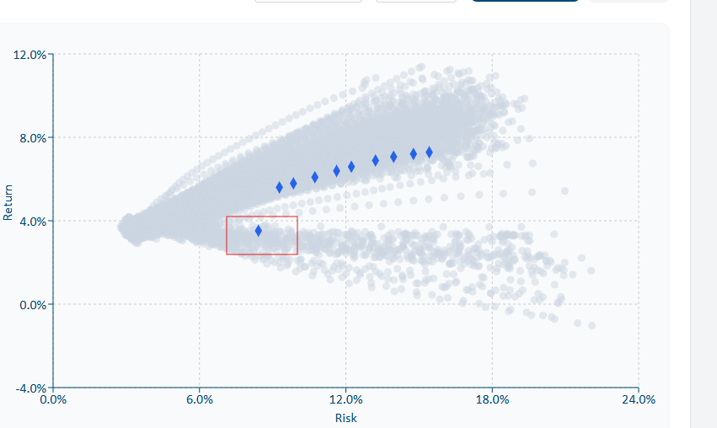
- Can the “Simulations” box be moved to the hidden widget page

Output
- Perhaps portfolio 1 should be removed as an option as it will never be selected, and rename portfolio 2 as portfolio 1, portfolio 3 as portfolio 2 etc. Then add one portfolio to the right of portfolio 10
- When I ran a two or three-entity scenario and applied a constraint to cash, it didn’t adhere to it – please check
- Can we change the “Total Portfolio” pie chart to be grouped into six main asset classes ie “Australian Equities”, “Global Equities”, “Property”, “Fixed Interest”, “Alternatives” and “Cash”. The pie charts per entity can remain granular

Projections
- When toggling from Before to After Tax, can we keep the Wealth Projection chart parameters the same so it doesn’t resize – easier to compare
- I can’t check the nominal / real values – have you checked that this is correct?
- Under Estimating Outcomes can we show the same time frame as for the Wealth Projection ie if 30 years chosen, then should be for both
- I don’t think the 1 and 2 standard deviation calculations look correct. I would expect a significantly larger downside than upside over time
- Remove “Year” after the year
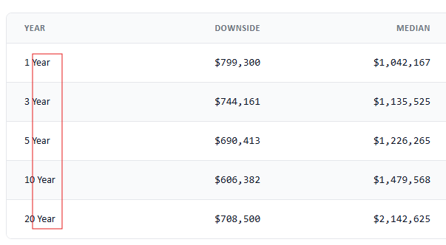

- Change format from all caps to regular
